APS Exchange Distribution Lists for Schools

The purpose of this document is to inform users about the design of the Exchange Distribution Lists and the proper way the lists must be managed to ensure their accuracy.

Each School has a set of three distribution lists. Examples are the following:

Display Name SMTP address
#Key Administrative Staff #key.administrative.staff@apsva.us
#Key Instructional Staff #key.instructional.staff@apsva.us
#Key Staff (All) #key.staff.all@apsva.us

#Key Administrative Staff (contains administrative staff)
#Key Instructional Staff (contains instructional staff)
#Key Staff (ALL) (automatically contains #Key Administrative Staff and the #Key Instructional Staff plus any additional staff who might not fall under the schools administrative staff or instructional staff groups however need to be included on schools all staff e-mails.

An example of the #key Staff (ALL) shows that the Administrative and Instructional Groups are nested (included) in the #key Staff (ALL) List:

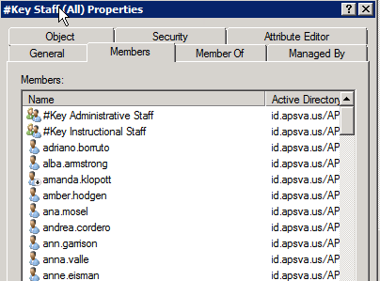

The properties show that the “#key Staff (ALL)” is a combination of the Administrative Staff, Instructional Staff group plus any additional staff who don’t fall under the schools Administrative or Instructional groups but need to be included on the All staff e-mails. In other words when someone is added to the Instructional lists or the Administrative list they are automatically added to the “All Staff” at the same time.

You can also see nesting of the groups in Outlook 2010 by double clicking on the Group and opening its properties.

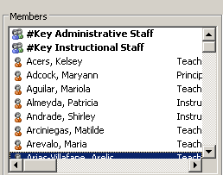

Verifying Distribution Lists

The Best way to verify the distribution lists is to use the “ExchangeDistributionGroupMembers” tool, which was designed for the verification process.

The “ExchangeDistributionGroupMembers” tool is located in:
z:\common\public\Exchange Distribution Group Tool

This tool must be run from a Windows 7 workstation that is a member of the APS domain. Standalone machines as well as MAC’s will not be able to use this tool.
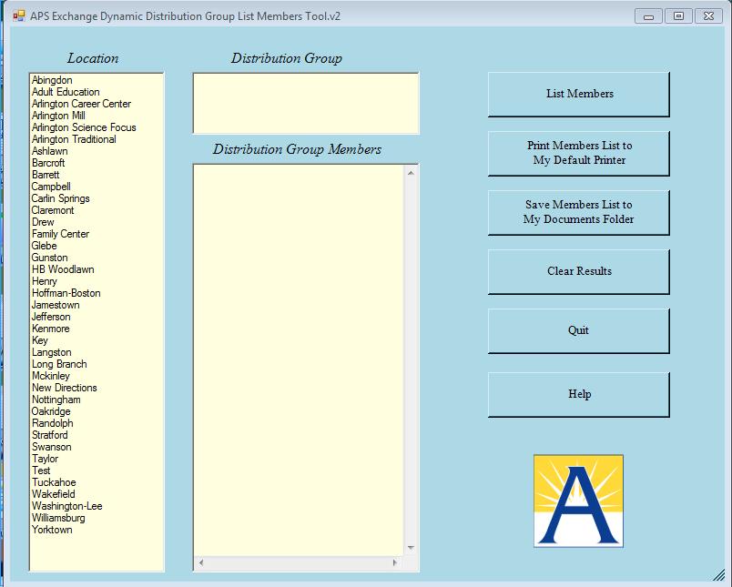

Once you launch the “ExchangeDistributionGroupMembers” you will see the screen above. Simply select your location and you will see three distribution lists displayed under “Distribution Group.” From here you can select the Distribution Group you would like to query/verify and select (List Member, Print Members, Save Members to text file).

